Goulburn
Family Day Care
An Anglicare NSW South, NSW West & ACT Early Childhood
Education & Care Service

Prospective Early Childhood Educator Information Booklet

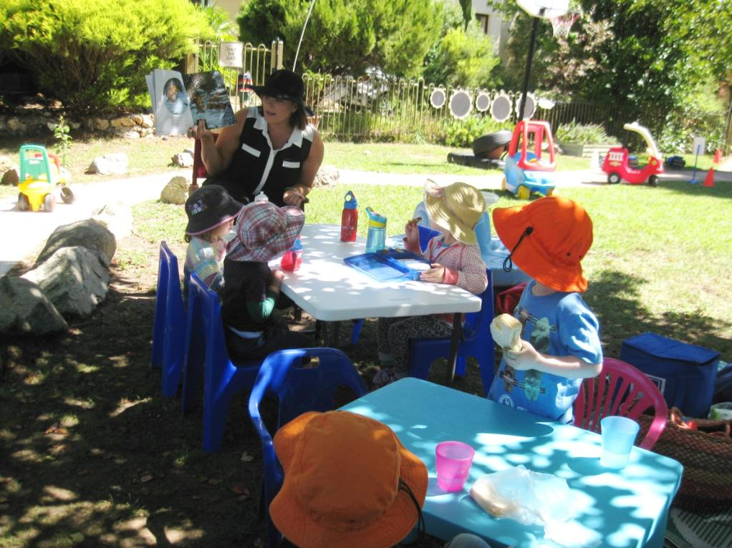

This booklet will answer the many questions you may have about the work of a Family Day Care Educator and the Scheme, which will help you consider whether this is the right working environment for you.

Early Childhood Educator
Application Pack

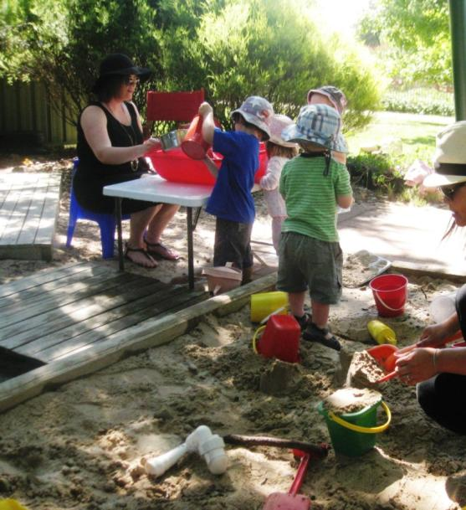
About Us

Our Early Childhood Education and Care services give your
child a valuable start by providing high-quality education and
care across a range of flexible programs. Our services across
the Canberra and Goulburn region include family day care,
preschool, long day care (full-
time, part-time and casual), after-school care, vacation
care and playgroup. We currently support over 1000
children and families across our early learning services.

Useful Websites
Anglicare NSW South, NSW West & ACT
www.anglicare.com.au
NSW Family Day Care Association
www.nswfdc.org.au
Family Day Care Australia
www.familydaycare.com.au
Australian Children’s Education & Care Quality Authority
www.acecqa.gov.au
Advocate for Children & Young People
www.acyp.nsw.gov.au
NSW Department of Justice
www.justice.nsw.gov.au
Dear Applicant
Thank you for your enquiry about becoming an Educator with Goulburn Family Day Care.
This booklet will answer the many questions you may have about the work of a Family Day Care Educator and the Scheme, which will help you consider whether this is the right working environment for you.
As a Family Day Care Educator you will need to:
- Hold a minimum Certificate III in Children’s services or be enrolled and actively studying towards achieving the Certificate III qualification
- Uphold the Anglicare values of Integrity, Compassion, Dignity and Inclusion
- Engage with Anglicare’s Sanctuary model of trauma informed practice
- Enjoy good health
- Implement excellent safety measures
- Have an enthusiastic attitude
- Be open to advice and suggestions and be prepared to have regular home visits from Goulburn Family Day Care staff
- Be patient, reliable, responsible and concerned for the welfare of children, and have no history of neglect, abuse or violence
Please read this booklet thoroughly before completing the Proposed Family Day Care Residence Risk Assessment followed by the Educator Application for Registration at the back of this booklet.
When you have completed your Residence Risk Assessment and Application for Registration, please make an appointment to return them to the Coordination Unit so that any questions you may have can be addressed in person.
If you have any other questions, please do not hesitate to contact me.
I look forward to receiving your application.
Kind regards,
Ashley Sturgiss
Director
Goulburn Family Day Care

Address 126 Cowper Street, Goulburn NSW 2580
Phone 02 4823 4052
Email goulburnfdc@anglicare.com.au
Web www.anglicare.com.au

Contents
What is Family Day Care? 6
Our Staff and their Role 6
Other Services Provided by the Scheme 7
Commitment to Providing Care & Education 8
Holidays/Illness & Time Off 10
Pregnancy 11
Taxation 11
Using Household Appliances & Machinery 11
Glass 12
Pets 12
Safety Requirements 13
Supervision Requirements 13
Providing Meals 14
Numbers of Children (Regulated Ratios for Family Day Care) 14
How Payment is Made 14
How Placement of Children is Made 15
Scheme Policies 16
The Registration Process 18
What to do Next 18
Proposed Family Day Care Residence Risk Assessment 21
Educator Application for Registration 25
Medical Clearance Letter 31
Approval from Owner/Landlord 33

What is Family Day Care?
Family Day Care is a child care service where children are educated and cared for in small family groups in the homes of Registered Educators. Quaified Educators ensure an excellent early learning program is implemented for each child every day.
Family Day Care is licensed and regulated by the Department of Education and Training and funded by the Commonwealth Government. It provides care and education for children aged 0-12 years in the homes of Registered home-based early childhood qualified Educators with the support, guidance and monitoring of qualified and experienced early childhood staff employed by an approved Scheme, referred to as the Coordination Unit.
Our service is inclusive of families of all religions, cultures, backgrounds and to children with additional needs and offers care & education on a full-time, part-time, occasional, before and after school or emergency basis. Families experiencing emergencies or with non-standard working hours may also able to access care on weekends, evenings and overnight (for work purposes) as required.
Our Staff and their Roles
Our staff are qualified and experienced in early childhood education and care and are able to assist you with any issues in the provision of care. The Coordination Unit is available on 02 4823 4052.
Nominated Supervisor and Office Administration: Ashley Sturgiss
Educational Leader: Skye Lewis
Playgroup Leader: Rhonda Perry

All staff have current Working with Children Checks, National Police Clearances, first-aid, asthma and anaphylaxis qualifications and undertake a variety of training each year to keep abreast of changes in the early childhood industry.

Our role is to provide Educators with:
- Advice and assistance to overcome difficulties in dealing with parents or guardians, caring for children and paperwork
- Training & Professional Development (see section on Other Services Provided by the Scheme)
- Support and guidance complying with regulatory and legislative requirements
- Assistance in carrying out duties in a business-like and professional manner
- Resources, information packages and special programs to meet the needs of individual children where necessary and at special times of the year
- Access to play sessions known as Playgroup and excursions
- Assistance with selection of suitable toys and equipment as needed
Our duties also include:
- Visiting the home of Educators each fortnight to monitor children’s progress, the care & education environment and training needs
- Carrying out formal observations of children’s development and learning.
- Role modelling & leading Playgroup sessions
Other Services Provided by the Scheme
Playgroup
This provides you with an opportunity to participate with the children in a wider range of activities. The children participate in larger groups to extend their social skills whilst you are able to develop professional support networks with other Educators. Playgroup attendance is not compulsory but it is valuable to your work and is highly recommended by the Coordination Unit staff and our team of Educators.
Toy Library
This provides a wide range of play & learning equipment for all ages of children. These items are available for loan as required. There is no cost involved, however breakages due to improper use must be paid for.
Resource Book/Video/DVD Library
This provides a wide range of books, videos and DVDs covering many topics relevant to your work. These items are available for loan as required. There is no cost involved.
Training & Professional Development
Newly Registered Educators must complete Orientation & Induction Training which involves some face-to-face and some self-paced modules, covering the National Quality Standards, Early Years Learning Framework, Education & Care Services National Regulations and National Law, Child Protection, communication, child development, behaviour guidance, administration and WHS, as well as practical hands-on components.
Educators will be expected to engage in Sanctuary and Anglicare Values training and be provided with ongoing support to implement the tools and commitments of the Sanctuary model.
In-service training workshops are provided throughout the year. Workshop topics are chosen in consultation with Educators. Some workshops will be compulsory, others optional (but highly recommended). All Educators must engage in at least 2 workshops/professional development modules each calendar year to continue with their Registration. Workshops are usually arranged and tailored to individual goals/needs as well as the overall group.
Commitment to providing Care & Education
Before becoming a Family Day Care Educator you will be required to:
- Undergo a National Criminal Record Check along with any other household members aged 18+ years (this is undertaken by Anglicare and there is no charge to you or household members)
- Obtain a Working With Children Check along any other household members aged 18+ years (the fee is $80 for you but no charge for household members)
- Obtain a medical clearance from your doctor to say you are fit and healthy to work with children
- Have or obtain First Aid, Asthma & Anaphylaxis management qualifications prior to commencement
- Complete a Proposed Family Day Care Residence Risk Assessment for suitability as a care environment
- Have referees who will be happy to provide written and/or verbal references to support your application
- Undertake an orientation/training process
What will be expected of me as an Educator?
During care hours you should consider your home to be your workplace and conduct yourself in a friendly, but business-like manner. For example:
- Communicate with parents or guardians (your clients) in an open and honest manner
- Be reliable and available at agreed times and days
- Restrict your housework, sporting and leisure activities, appointments and your shopping to before/after working hours
As a Family Day Care Educator you must also work at all times within the National Quality Framework (NQF). The NQF provide a learning framework and regulations that state you must:
- Provide an environment where children are safe and protected at all times
- Provide constant supervision of children
- Respect the privacy and confidentiality of parents or guardians and children and discuss situations with Coordination Unit staff only (not other Educators, friends or your family members)

- Work with parents or guardians in the education and care of their child by discussing the child’s daily needs, showing empathy and respect for the parents or guardians values, beliefs or the reasons they use care and offering support and sympathy to a family’s needs
- Limit the number of children you care for at one time (follow the regulated ratio)
- Spend time engaging authentically with children tosupport and encourage them to become independent while alsoprovide for their physical needs, e.g. toilet learning, regular nappy changing, quiet areas & nutritious food, as well as providing for their emotional needs
- Plan for children’s interests and needs, taking into account their strengths, capabilities, cultural interests and experience
- Observe children’s learning, plan for their future needs and complete all necessary documentation
- Participate in professional development and in-service training, Scheme meetings and Playgroup when arranged
These are some of the key elements of the regulations – a full copy will be provided to you before finalisation of your Registration.
You will not be expected to:
- Care for sick children
- Wash nappies/clothing or sterilise feeding equipment and make up infant formulas
- Continue caring for a child if insurmountable difficulties occur (after attempts to resolve the problem have failed)
What about my other commitments?
You are encouraged to go on outings, e.g. visiting libraries, parks, playgroups, concerts, displays, etc. as long as parents or guardians have agreed in writing and you can still adequately supervise the children. Other activities, e.g. visiting friends, helping at your child’s school, playing sport, hobby groups, etc. must be left for after work hours.
You must carefully supervise children at all times when visited by friends or relatives (these people may not be as aware of safety as you will become). All visitors must sign a Visitor’s Book. Where a visitor attends the care premises on a “regular” basis, families must be informed and a Working With Children Check must be obtained.
Other considerations
You should consider the days, hours and length of time you are willing to commit to providing Family Day Care and your family’s lifestyle, e.g. shift-working partner.
Children quickly form bonds with their Educator. It is distressing for both the child and parent or guardian if their Educator frequently takes days off, has excessive amounts of holidays or decides to discontinue care after only a short amount of time.
Before committing to provide care you should consider carefully your availability, your other commitments and your family needs.
Providing a Family Day Care service is a rewarding experience and is a valued early childhood education and care option for parents or guardians and children. You will become an important part of many young children’s lives.
It will allow you to be involved in the workforce, earn an income in your own home, have access to a range of resources and assistance and continue to care for the needs of your own family.
If you enjoy building positive relationships with children and their families then we would be thrilled to have you join our team!
Holidays, Illness & Time Off
You are at liberty to take holidays at any time throughout the year, however you should provide both the Coordination Unit and your families with as much notice as possible (minimum two weeks).
We will, to the best of our ability, arrange alternate placement of children in your care for the period of absence in the case of illness with regard to yourself and/or your own children, or for your holidays.
Alternate care can also be arranged for you to take “time off” to attend to urgent matters, with a relief Educator when available.
If you are frequently unavailable to provide care the Director will assess with you whether your Registration and bookings need to be renegotiated.
If you are unavailable to care for any reason you are unable to charge a fee for that time. You should therefore plan your finances to avoid over commitment of earnings.

Parental Leave
Please advise the Director if you or your partner are considering pregnancy or adoption.
Pregnancy is not a reason for rejecting your application, however, it may have a bearing on the type of placements made until after your parental leave to ensure your health and safety and t reduce the disruption to families using your program.
Maybe refer to the parental leave policy.
You can remain Registered while on leave for a period of 6 months. If longer leave is required you will need to reapply for Registration when ready to return.
Taxation
Family Day Care Educators are regarded as being Self Employed by the Australian Taxation Office, not employees of the Scheme. You will need an Australian Business Number (ABN) and a business Tax File Number.
You will be responsible for the payment of tax on earnings and for keeping records of your income and expenditure. Your home is your principle place of business. This means that you run your business from home and an area of the home is set aside exclusively for these business activities. Many tax deductions are available, e.g. a proportion of your electricity, rent or mortgage interest payments, car registration, repairs, cleaning costs, etc. and we recommend you use an accountant or tax agent to ensure you receive the maximum benefit.
Further information is available on the Australian Taxation Office website www.ato.gov.au.
Using Household Appliances & Equipment
Household appliances should be used with extreme caution at all times.
- Electrical appliances should be unplugged and placed in a cupboard whenever possible.
- Never leave electrical cords dangling
- Electric jugs and kettles must be emptied after each use
- Saucepans, frypans, woks, etc. must be used with extreme caution only by an adult and filled with cold water immediately after use. Children should not be given access to your kitchen while these items or ovens are in use
- Electric mixers and toasters are to be used by an adult only and should be put away immediately after use
- Vacuum cleaners (except dust busters), sewing machines and overlockers, irons and ironing presses, etc., mowers and lawn trimmers and exercise equipment must be used out of care hours only.
- All power points should have a safety power point plug inserted when not in use.
Glass
Any glass in an area that is accessible to children and situated 750mm or less above the floor level is required to be toughened safety glass or treated with a product that prevents glass from shattering if broken (such as safety film), or otherwise guarded with barriers to prevent a child from hitting or falling against the glass.
Information will need to be provided prior to final Registration that the glass in your care environment meets the correct standards or has been made child safe, and the Coordination Unit can help you with information on how to do this.
Pets
All pets at your home must be kept in an area which is inaccessible to children. Keeping dogs on chains and runs is insufficient.
You must keep outdoor play areas free of food and water containers, faeces and holes dug by pets.
You may allow children contact with small pets whilst the pet is under your close physical control and supervision for short periods only and the parent or guardian has given written permission. If permission is granted, it should be identified as an activity on your program.
You must ensure your pet is free of skin complaints, vaccinated and wormed regularly and is well maintained.
If you are unsure how your pet will react with children, then arrange for the pet to be confined away from children while your program is operating.

Safety Requirements
We will need to conduct a thorough Proposed Family Day Care Residence Risk Assessment of your indoor and outdoor environments before Registration and at frequent intervals while you are providing care & education.
You will be given a Proposed Family Day Care Residence Risk Assessment with this booklet. Please read the document carefully. If you are concerned about any items listed please discuss this with the Director.
We can often suggest a way concerns can simply (and cheaply) be rectified.
After your Proposed Family Day Care Residence Risk Assessment has been conducted, you will be provided with verbal and written details of any items found to require attention and these will need to be completed before Registration can take place.
You are also considered a workplace, so should meet the requirements of WHS regulations.
Supervision Requirements
You are responsible for providing constant supervision of children. You should arrange your home so you can constantly see, hear and be aware of what children are doing both indoor and outdoor with the children.
You must keep yard gate latches in place and locked during care hours and exterior doors locked when indoors.
If a child is sleeping in another room you must leave the door ajar and physically check the child, completing a sleep chart regularly. You may never go outdoors with other children while a child (including a baby) is asleep indoors. The use of a baby monitor does not replace your supervision requirements.
We recommend the use of mobile phones, cordless phone and answering machines if you have concerns about missing calls and/or are likely to receive many or lengthy calls.
Educators should not be using the internet or email during program, hours, unless it is part of an educational experience with children in care and reflected in programming documentation.
Providing Meals
Most families enrolled prefer to send meals and snacks along with their child, however you may occasionally be asked to provide meals for the child in your program (particularly in night time care situations or if the parent or guardian is running late on a particular day or has not packed sufficient food).
If you provide meals on any occasion a fee is payable by the parent or guardian for each meal or snack provided. All meals must be nutritious and varied and take into account the family’s beliefs/culture.
Educators must register with the local council if they are going to be providing meals on a regular basis and undertake training on Food Safety Handling.
Numbers of Children (Regulated Ratios for Family Day Care)
Please note numbers INCLUDE any children of your own under 13 years of age.
You may care for up to 7 children at one time on your premises, HOWEVER:
- Only 4 of these children may be under school age at any one time
- If you have 4 children under school age, you may provide care & education for 3 children of school age at the same time
Your own children and their friends visiting without an adult ARE to be counted if they are under 13 years of age and there is no other adult present and able to care for the children. You may work with a lesser number of children if you wish.
How Payment is Made
As a service funded by the Commonwealth Government we offer eligible families access to Child Care Subsidy (CCS). All fees are charged on an hourly basis for each child in care and parents or guardians are responsible for payment of fees direct to the Educator each week or fortnight as agreed. All booked care is paid for even if the child leaves early or is absent for any reason. Families who are eligible to receive CCS pay the difference between their entitlement for CCS and the full fee. The balance is paid to the Educator by the Scheme each fortnight.
For permanent placements:
- Absences are charged the usual fee
- Where care is used on a public holiday a higher fee can be paid.
Educators set their own fees and these fees need to comply with Scheme Policies. These can be discussed with the Director.
How Placement of Children is Made
STEP 1 – Parents or guardians call the Coordination Unit to enrol their child and discuss their requirements and expectations. We also inform them of Scheme Policies.
STEP 2 – The Director assesses current vacancies, the family’s needs and your preferences for care to determine the most appropriate placement for the child.
STEP 3 – The Coordination Unit will contact you to ask whether you agree to the placement.
STEP 4 – If you agree, your name will be given to the parent or guardian along with the names of other available Educators.
STEP 5 – The parent or guardian will contact you directly to arrange a mutually convenient time to discuss the placement and will bring an Application for Enrolment-Child Placement Agreement.
This is your opportunity to present your home and showcase the wonderful program you provide for young children.
STEP 6 – After visiting each Educator the parent or guardian will make their selection. If chosen, the parent or guardian will contact you and arrange a first day and time. The Coordination Unit will contact you if the parent or guardian has chosen another Educator.
You may reject a placement (before or after interviewing the parent or guardian) if you:
- Know the family in another capacity, e.g. a friend, workmate or family member, neighbour, etc. and feel it may affect the relationship
- Feel that you do not have the skill/knowledge/experience to effectively engage with the child or parent or guardian placement
- Feel that it would be detrimental to other children already in care (or your own children) to accept the placement
- Feel you are currently working to your capacity

- Are unable to fully satisfy the requirements for care, e.g. transport, non-standard hours of care, etc.
- Feel it would create difficulties with other family members
Scheme Policies
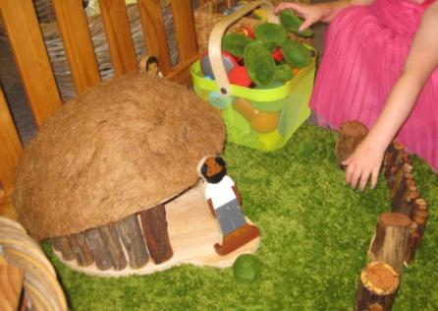
Policies are developed in consultation with Coordination Unit staff, Educators, parents or guardians and where applicable, the community. A full copy of the Scheme Policies is available for inspection at the Coordination Unit and a copy is given to all Registered Educators. Once an Educator is Registered a current policy document must be available at the Educator premises. Policies include items such as:
Tobacco, Drug and Alcohol Use
You must at all times provide a tobacco smoke, drug and alcohol free environment for the children, including indoors, outdoors and on outings.
Food and Nutrition
Parents or guardians and Educators are to provide food and drinks that are nutritious, adequate in quantity and offered at frequent intervals to children while attending the program. Provision is made, however, for celebration of birthdays, cooking activities, special treats, etc.
Providing a Child Save Environment – Indoor & Outdoor
Children have a right to an indoor play space that promotes safe exploration, learning through play and interactions.
All resources and equipment will be chosen to meet the children’s developmental needs, strengths and interests.
Children have a right to an outdoor play space that promotes safe exploration, learning through play and interaction with the natural and built environment.
All experiences, indoors and outdoors, will be closely supervised at all times having regard to the need to maintain the rights and dignity of the children.
Any play equipment must comply with Kidsafe recommendations. More information is available from the Coordination Unit office or on the Kidsafe website www.kidsafe.org.au.

Hazardous Chemicals and Equipment – Medication
First Aid Equipment and medications must be kept in a child resistant locked cupboard or container out of reach of children. Medication needing refrigeration must be kept in a child resistant container in the refrigerator labelled with the child’s name.
Cleaning materials, toiletries, disinfectants and other poisonous/dangerous substances must be stored in their original containers that are labelled with a description of their content and directions for their use. These containers must be stored in a secure storage facility that is inaccessible to children.
Confidentiality
All information gathered regarding children, families, Educators or Coordination Unit staff is strictly confidential and must be kept so as to prevent access by unauthorised persons. Information you may hold relating to children or their families should be discussed with the parents or guardians of the child, Coordination Unit staff or those authorised by law to have access to such information only.
Any personal information provided to you is protected under the Privacy Act 1988 and breaches of this Act and the Regulations can attract severe penalties.
Interactions with Children
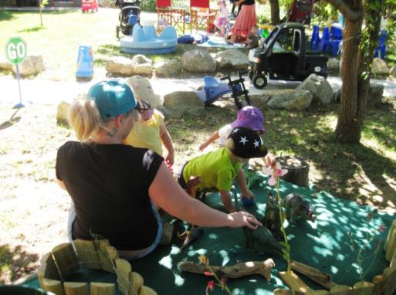
Actions which are intended to threaten, humiliate or frighten the child, including smacking, force feeding, and isolation must NEVER be used in any form when dealing with children’s behaviour.
Swearing, use of humorous or pet names for children, disparaging terms and shouting must not be used. No form of physical or psychological abuse should occur at any time. Should difficulties arise with children’s behaviour Coordination Unit staff will assist to develop and implement a plan of action for overcoming inappropriate actions.
Educators must focus on positive behaviour guidance strategies so as to instil qualities of independence, co-operation, problem solving skills and the development of a positive self image are encouraged at all times.
Should you wish to discipline your own children this must be done in a manner as outlined above.

The Registration Process
You have taken the first step in becoming a Family Day Care Educator by requesting this information package.
Should you decide to continue, you should make an appointment to return your completed Proposed Family Day Care Residence Risk Assessment, Application for Registration and medical clearance certifying your fitness to provide care for children. We will then require a National Criminal Record Check and Working With Children Check. We will also forward a short request for information to people you nominate as referees to ask them about your character and suitability to provide care.
The details you provide on your application, your responses to the questions discussed at your interview and the results of checks conducted in your home, your criminal record and referees will be assessed.
You will be asked to obtain the consent of your landlord if you are living in rented premises and we will undertake a thorough Proposed Family Day Care Residence Risk Assessment.
You may also be asked to attend an Educator’s residence or a Playgroup session so that we may assess your interactions with children.
When you have completed the above we will contact you and let you know whether we can offer you Registration as a Family Day Care Educator. If you are offered Registration with our Scheme you will be booked into our Educator Orientation & Induction Training Program, designed to give you in-depth information on becoming an Educator and the requirements of being an Educator.
You will be provided with copies of Government Regulations, National Quality Framework and Registration Resource Folder. You will need to have current First Aid Qualifications and to have taken out Public Liability Insurance and have a final Family Day Care Residence Risk Assessment completed before you can accept children in care.
All newly registered educators are asked to pay a non-refundable fee of $150 on top of the Annual Registration Fee. This ensures that should a change of mind occur, the service is able to cover costs attributed throughout the recruitment process.
What to do Next
If you have discussed the information contained in this booklet with your family and have decided you would like to become an Educator, please:
- Complete the Proposed Family Day Care Residence Risk Assessment
- Complete the Educator Application for Registration form
- Obtain a medical clearance from your doctor
- Contact the people you name as referee to let them know you have provided us with their names
- Complete (with all adult members of your family) the National Police Checking Service consent forms
- Obtain (with all adult members of your family) a Working With Children Check
- Make an appointment to return all the forms above to the Coordination Unit and discuss your application further.
Again, caring for young children is a rewarding occupation. We look forward to receiving your application and/or answering any other questions you might have.
For further information contact
Ashley Sturgiss
Director
Goulburn Family Day Care
126 Cowper Street, Goulburn NSW 2580
Phone 02 4823 4052
Email ashley.sturgiss@anglicare.com.au
Web www.anglicare.com.au

The Australian Government provides financial support for Family Day Care under the Community Support Program.

GOULBURN FAMILY DAY CARE
126 Cowper Street, Goulburn NSW 2580
Phone 02 4823 4052 Fax 02 4823 4055
Email goulburnfdc@anglicare.com.au

Proposed Family Day Care Residence Risk Assessment
(Complete and return with Application for Registration)
“Shop Front” Entrance
Address of residence
House number visible
Easily accessible
Presentation
Front/back doors/security doors locked
Comments
Living Area
Clear and clean spaces and surfaces
Safety areas – power plugs/cords
Fans/heaters/fireguards
Child appropriate furniture
Comments
Inside Play Area
Activities offered
Toys and equipment
Storage
Set-up areas
Multi-cultural toys/equipment
TV’s/Computer usage
Comments
Children’s Sleep Areas
Location
Beds and bedding
Waterproof protection
Safety issues
Comments
Kitchen Area
Stove knobs
Childproof locks
Medication storage
Alcohol
Knives, plastic bags
Eating space
Clear and clean food preparation surfaces
Comments
Bathroom Area
Tap covers/regulated water
Individual Towels
Access
Cupboard locks
Suitable Nappy Change Area
Equipment
Change Mats
Safety
Comments
Laundry Area (only if children are to have access)
Is it a traffic area?
Storage
Chemicals
Comments
Outside Play Area
Activities offered
Safety
Equipment
Lawns and surrounds
Fencing
Gates
Shade
Hazards
Pet droppings cleared
Hats outside/sunscreen
Comments
Animals
Location
Cleanliness
Access
Feeding area
Comments
This page has been intentionally left blank
GOULBURN FAMILY DAY CARE
126 Cowper Street, Goulburn NSW 2580
Phone 02 4823 4052 Fax 02 4823 4055
Email goulburnfdc@anglicare.com.au

Educator Application for Registration
(Complete and return with Proposed Family Day Care Residence Risk Assessment)
Your personal details
Applicant full name
Date of birth _____ / _____ / ____________ Gender Male Female
Address of residence
Postal address (if different)
Telephone home Mobile number
Email address
Country of birth Marital status
Primary language spoken at home
If your primary language is a language other than English, please answer the following questions:
Level of Spoken English (please tick) Excellent Very Good Good Fair Poor
Level of Written English (please tick) Excellent Very Good Good Fair Poor
Your partner’s details (if applicable)
Name of partner
Date of birth ____ / _____ / ____________ Gender Male Female
Occupation
Hours of work Mobile number
Your children’s details (if applicable)
Name Date of birth _____ / _____ / ____________
School/Occupation
Name Date of birth _____ / _____ / ____________
School/Occupation
Name Date of birth _____ / _____ / ____________
School/Occupation
Qualifications/Experience/Criteria
Do you have any formal qualification in child care/children’s services? Yes No If yes, please provide copies of your qualifications.
If no, are you prepared to commence study in Cert III in Children’s Services? Yes No
Have you previously been employed by or registered with an early childhood education and care service, e.g. family day care scheme, long day care service or preschool? Yes No If yes, please provide details.
Please briefly describe your experience working with or providing education & care for children. This may include unpaid positions and your own children (please include number and ages of children).
Have your services ever been terminated? Yes No If yes, please provide details (attach a separate page if necessary).
Are you currently working? Yes No
Do you have a Working With Children Check clearance? Yes No If yes, please advise the following:
WWCC Number Expiry Date
If no, please note this is a requirement of registration as a Family Day Care Educator.
Are you, and any person aged 18 years or older living at this residence, prepared to undergo a Working With Children Check? Yes No The fee is $80 for an Educator but no charge for household members.
Do you have a current first aid certificate? Yes No If yes, please advise the training provider:
Date Completed Expiry Date
Is the CPR component of your first aid certificate current (within the last 12 months)? Yes No
Do you have a current certificate in:
Emergency Asthma Management Training? Yes No
Emergency Anaphylaxis Management Training? Yes No
Are you, and any person aged 18 years or older living at this residence, prepared to undergo a National Criminal Record Check? Yes No Undertaken by Anglicare and there is no charge.
Are you a smoker? Yes No
If no, are there any smokers living at the residence? Yes No
Have you read, and did you understand the Goulburn Family Day Care Prospective Educator Information Booklet? Yes No If no, please explain why not.
For what period of time can you commit yourself to Family Day Care, e.g. 5-10 years?
What ages of children would you prefer to care for? Please provide a range
What days/hours do you envisage your Family Day Care service would operate? (please tick relevant type/s)
Full time hours five days per week Part time hours and/or two – three days per week
Before and after school care hours Casual (no set times or days) Weekends
Overnight Emergency Care
Why do you wish to become (or continue to work as) a Family Day Care Educator and what personal and professional qualities do you possess that would contribute to your suitability in the role of Family Day Care Educator?
Briefly describe your general expectations of Goulburn Family Day Care to support you in your role as a Family Day Care Educator?
How do you plan to provide a stimulating environment for children in your Family Day Care service?
Do you have any challenges in your personal or family circumstances which may need to be addressed in relation to becoming a Family Day Care Educator (this may include medical conditions, family/study commitments, etc.)? Yes No If yes, please explain.
Have you discussed your intentions to operate a Family Day Care service from your residence with the members of your family residing with you? Yes No If yes, please describe the level of family support you have received and any concerns or issues raised by family members.
Parents or guardians and Coordination Unit staff need to visit your residence at different (often unannounced) times throughout the day whilst children in care are on the premises. How will you feel about this?
One component of providing quality care for children is to continually improve your own professional development. In what ways do you think you could achieve this?
How do feel about attending professional development out of hours (evenings and weekends)?
As you are self-employed you need to keep accurate records for regulatory bodies, the Family Day Care service, and your business taxation requirements. How comfortable do you feel about coping with this aspect of your Family Day Care business?
Do you have any concerns about your home environment which may affect your ability to provide a safe physical environment for children? Yes No If yes, please explain.
Do you have any pets? Yes No If yes, please describe the types and number of animals and the areas of your residence they will have access to during Family Day Care hours of operation.

Is your residence a rental property? Yes No If yes, do you have permission from your landlord to operate a Family Day Care service from the residence? Yes No If no, you will need to obtain permission from your landlord to operate a Family Day Care service from the residence.
Please provide two referees not related to you:
Name Phone
Address Relationship
Name Phone
Address Relationship
I hereby state that the information I have provided in this form is true and correct to the best of my knowledge.

Signature of Applicant | Date

Collection Statement
Any personal information you provide is protected under the Privacy Act 1988 and is collected for the purpose of providing service or care appropriate to your needs. It can only be disclosed to someone else if you have been given reasonable notice of the disclosure; where disclosure is authorised or required by law or is reasonably necessary for the enforcement of the criminal law; if it will prevent or lessen a serious and imminent threat to a person’s life or health; or if you have consented to the disclosure. If you have questions or concerns about how your personal information is handled you can contact the Privacy Officer at Anglicare by emailing privacy@anglicare.com.au.

This page has been intentionally left blank
GOULBURN FAMILY DAY CARE
126 Cowper Street, Goulburn NSW 2580
Phone 02 4823 4052 Fax 02 4823 4055
Email goulburnfdc@anglicare.com.au

Medical Clearance
Dear Doctor,

As Nominated Supervisor of Goulburn Family Day Care, I am required by the Education and Care National Regulations 2012 to ensure that all Educators registered with our Service comply with these Regulations.

Under, Clause 82 (2), Tobacco, Drug and Alcohol Free Environment, it states:
“A family day care educator must ensure that children being educated and cared for by the educator as part of a family day care service are provided with an environment that is free from the use of tobacco, illicit drugs and alcohol. Penalty: $2000
Note: A compliance direction may be issued for failure to comply with subregulation (1).”
And Clause 83 (3) states:
“A family day care educator must not, while providing education and care for children as part of a family day care service –
(a) consume alcohol; or
(b) be affected by alcohol or drugs (including prescription medication) so as to impair his or her capacity to provide education and care to the children. Penalty: $2000
Note: A compliance direction may be issued for failure to comply with subregulation (1).”

Additionally, our Service Policies state that an Educator is expected to be of good health and free from any medical condition or dependency on any medication or substance that may affect their ability to care for children, and a medical clearance is required annually confirming his or her physical and emotional fitness to care for children.

A Family Day Care Educator is required to:
- provide education and care in their home for up to seven (7) children at any one time, with a maximum of
four (4) preschool aged children at any one time;
- be the sole education and care provider;
- provide education and care for up to ten (10) hours, five (5) days per week;
- lift children, e.g. in and out of vehicles, in to high chairs, on to change tables; and
- ensure that each child enrolled in their Family Day Care Service is adequately supervised at all times while education and care is being provided.
Accordingly, It would be appreciated if you would complete the section below for our records.

Sincerely,
Ashley
Ashley Sturgiss, Director

MEDICAL PRACTITIONER CLEARANCE
I, __________________________________________________ being a registered Medical Practitioner hereby confirm that proposed Family Day Care Educator _______________________________________________ has the emotional and physical ability to care for children in her own home to meet the requirements listed above.
Signature _________________________________ Provider No. _________________________ Date ____/____/____
Practice Stamp:

This page has intentionally been left blank
GOULBURN FAMILY DAY CARE
126 Cowper Street, Goulburn NSW 2580
Phone 02 4823 4052 Fax 02 4823 4055
Email goulburnfdc@anglicare.com.au

Approval from Owner/Landlord/Managing Agent to conduct a
Family Day Care Business at Leased Premises

Name of Proposed Educator
Address of residence

To be completed by the Owner/Landlord/Managing Agent of the above address.

I, (name)
being the Owner/Landlord Property Manager
of the residence situated at
give approval for (name of lessee)
to conduct a Family Day Care business at this address, educating and caring for young children.
Name of Managing Agent (if applicable)
Signature | Date

